Terrific result due to a well organised day and keen youngsters and coaches in conditions that were all against catching fish: water low and clear, low temperature, few flies about, chill downstream wind. So the catch successes were all the more creditable in those conditions.
Here are a few pictures. (Sorry I didn’t catch Tony and Cameron on camera!)

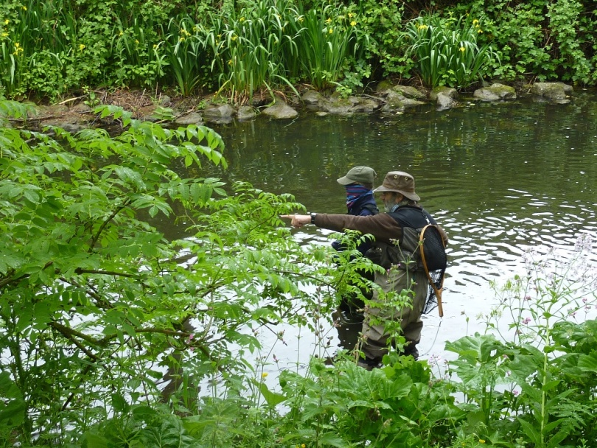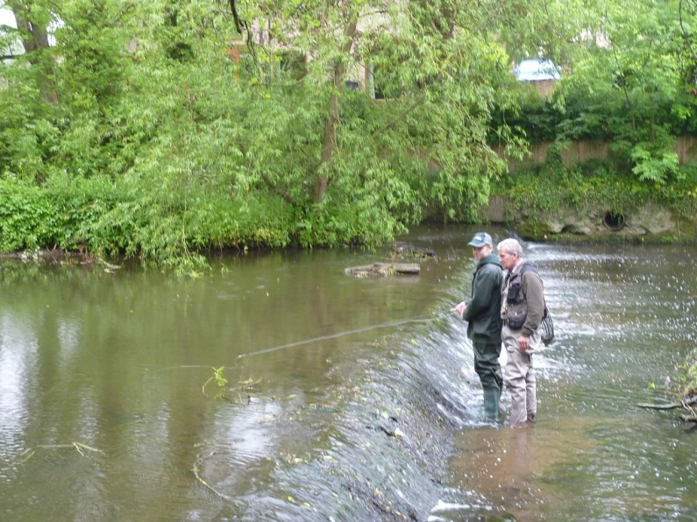
John and Daisy Jeff and Alex.
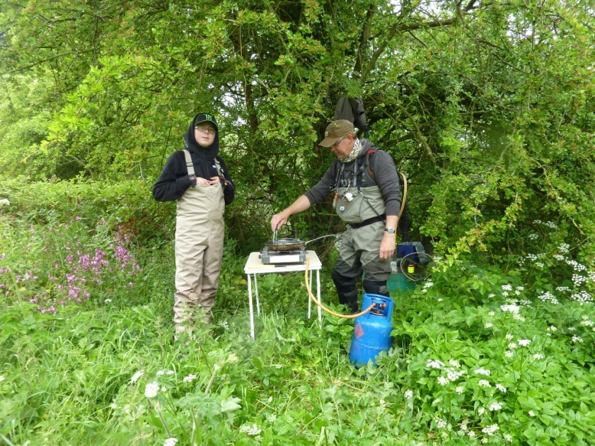
Scott (cooking well-earned bangers) and Taylor

